

SCHOOL OF ADVANCED TECHNOLOGY

ICT - Applications & Programming

Computer Engineering Technology – Computing Science

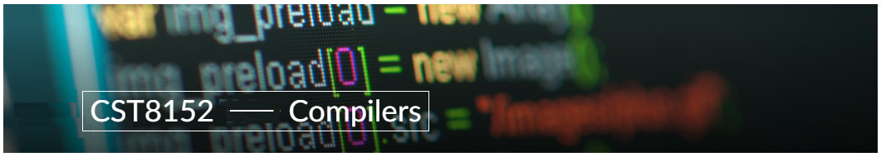

A21
Model Definitions (RE/Automaton)

Lab Professor / Lab Session:
[Prof Paulo Sousa / Section 301]

Team:
[Hayden Martens] - Id: [04567878] / [Allen Wong] - Id: [040847082]

Language Name [Viper]

This template is suggested (not mandatory) to answer A11 Specification.

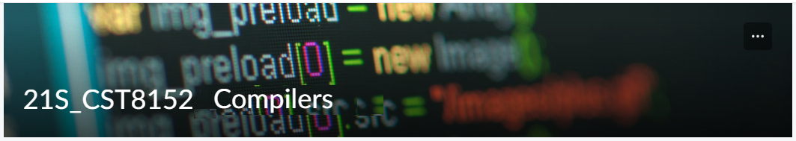

MODEL TASK FOR ASSIGNMENT 2.1 – YOUR LANGUAGE

- Note: This task is part of the Assignment 2 from Compilers Course. Any problem, contact your lab professor.

Task 1: Language Symbols (2.0 marks)

List examples: Define main symbols to be used:
- Special symbols (ex: “{“, “(“, “<=”, etc.)
- Comments
- Variables
- Functions
- Literals (numbers, strings)
- Keywords
- Datatypes

Answer:

Comments = {#comment here}
Keywords = {def, if, else, then, while, return, try, except, do, while}
Datatypes = {viper_int, viper_float, viper_void, viper_str, viper_char, viper_byte, viper_bool}
Special Symbols = {#, \n, ;, (, ), ‘, “, <, >, ==, !=, +=, -=, ++, --, &, *, _, …}
Variables = {[datatype] [variable]:, ex: viper_str myString: }
Function = {[return type] [function name] ([parameters]):, ex: viper_int myFunction(viper_bool input): }
Literals = {int = 1, 2, 3…, float = 1.618, string = ‘string’, “anotherString!”}

Task 2: RE – Regular Expression (3.0 mark)

Lexeme Classes: Define the classes to be used in your regular expression:

Answer:

H = ‘#’ (Comments)
N = ‘\n’ (New line)
L = a..z|A…Z (Letters/chars)
D = 0…9 (Digits)
P = . (Period)
Q1 = ‘ (Single quotes)
Q2 = “ (Double quotes)
B1 = ( (Left bracket)
B2 = ) (Right bracket)
C = , (Comma)
E = : (Colon)
U = _ (Underline)
O =[^HNLDPQ] (Other chars)

Define the RE to be used for: variables, literals and keywords:

Answer:
* Comments: H(^N)*N
* Variables: String : L(L|D)* Digits : L(D)*
* Methods: L(L|D|U|*B1
* Literals:
- Numbers D+
- Strings Q(^Q)Q = Q(L|D|P|C|E|O)*Q
* Keywords: L+{def | if | else | then | while | return | try | except | do | while}

Task 3: TD – Transition Diagram (3.0 marks)

Activity: Starting from the previous lexeme classes and obeying the RE, it is possible to define the automata for your language:

Answer (draw / copy image of the automata):

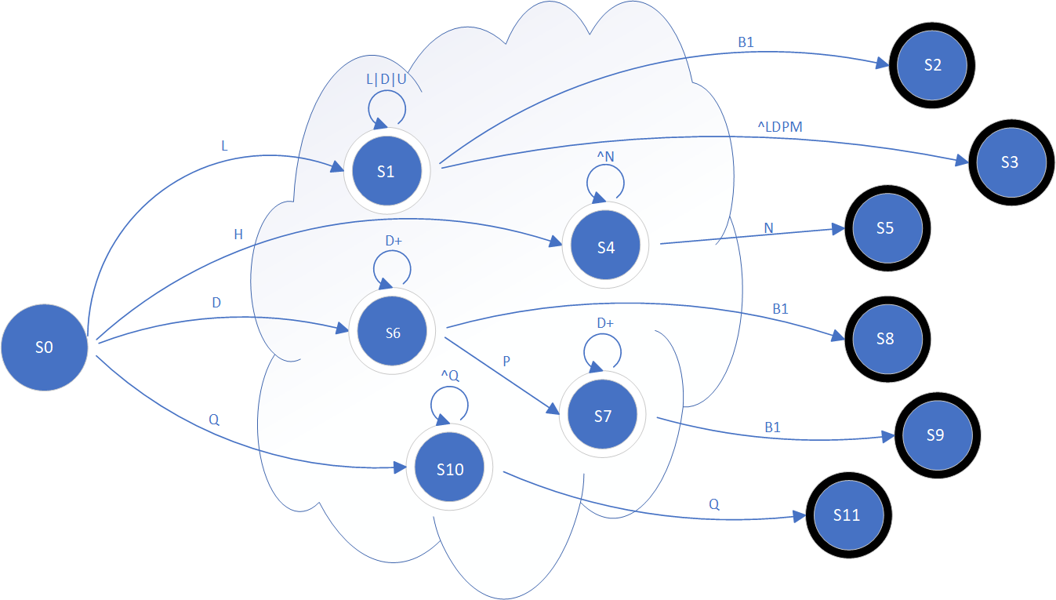

Task 4: TT – Transition Table (2.0 marks)

Activity: Now, it is possible to define the TT for these lexemes:

Answer (Transition Table):

Input | Input Symbols |  |  |  |  |  |  |  | Output
State\  Classes | 0 | 1 | 2 | 3 | 4 | 5 | 6 | 7 | Type
 | L (A-Z) | D (0-9) | P (.) | Q (‘) | B1 | O | H (#) | N (\n) | -
S0 | 1 | 2 | ESNR | S10 | ESNR | ESNR | ESNR | ESNR | NOAS [0]
S1 | 1 | 1 | 1 | 3 | 2 | 3 | 1 | ESNR | NOAS [1]
S2 | FS | FS | FS | FS | FS | FS | FS | FS | FUNC DEF [2]
S3 | FS | FS | FS | FS | FS | FS | FS | FS | KEYWORD [3]
S4 | 4 | 4 | 4 | 4 | 4 | 4 | 4 | 5 | NOAS [4]
S5 | FS | FS | FS | FS | FS | FS | FS | FS | COMMENT [5]
S6 | ESNR | 6 | 7 | ESNR | 8 | ESNR | ESNR | ESNR | NOAS [6]
S7 | ESNR | 7 | ESNR | ESNR | 9 | ESNR | ESNR | ESNR | NOAS [7]
S8 | FS | FS | FS | FS | FS | FS | FS | FS | INT [8]
S9 | FS | FS | FS | FS | FS | FS | FS | FS | FLOAT [9]
S10 | 10 | 10 | 10 | 11 | 10 | 10 | 10 | ESNR | NOAS [10]
S11 | FS | FS | FS | FS | FS | FS | FS | FS | STR LIT [11]

Update: Feb 4th 2024.

Adapted from resources developed by Prof. Svillen Ranev (Algonquin College, 2019)

